**INTERNATIONAL UNIVERSITY**

**VIETNAM NATIONAL UNIVERSITY – HO CHI MINH CITY**

**School of Computer Science and Engineering**

**-----\*\*\*-----**

**PROJECT REPORT**

**Minesweeper**

**Adviser: Dr Vi Chi Thanh**

**Course: Data Structure & Algorithm**

**Semester 2 (2024-2025)**

|  |  |  |  |
| --- | --- | --- | --- |
| No. | Full Name | Student’s ID | Contribution |
| 1 | Nguyễn Đức Nguyên Phúc | ITDSIU21108 | 100% |

**TABLE OF CONTENTS**

**[LIST OF FIGURES](#_Toc155965767)** [2](#_Toc155965767)

**[ABSTRACT](#_Toc155965768)** [3](#_Toc155965768)

**[CHAPTER 1: INTRODUCTION](#_Toc155965769)** [4](#_Toc155965769)

**[1.](#_Toc155965770)****[Objectives](#_Toc155965770)** [4](#_Toc155965770)

**[2.](#_Toc155965771)****[The tools used](#_Toc155965771)** [5](#_Toc155965771)

**[CHAPTER 2: METHODOLOGY](#_Toc155965772)** [6](#_Toc155965772)

**[1.](#_Toc155965773)****[Rules](#_Toc155965773)** [6](#_Toc155965773)

**[2.](#_Toc155965774)****[Design](#_Toc155965774)** [7](#_Toc155965774)

**[3.](#_Toc155965775)****[UML Diagram](#_Toc155965775)** [12](#_Toc155965775)

**[CHAPTER 3: DEMO – RESULT](#_Toc155965776)** [20](#_Toc155965776)

**[CHAPTER 4: CONCLUSION AND FUTURE WORKS](#_Toc155965777)** [23](#_Toc155965777)

**[1.](#_Toc155965778)****[Conclusion](#_Toc155965778)** [23](#_Toc155965778)

**[2.](#_Toc155965779)****[Future works](#_Toc155965779)** [23](#_Toc155965779)

**[3.](#_Toc155965780)****[Acknowledgment](#_Toc155965780)** [24](#_Toc155965780)

**[REFERENCES](#_Toc155965781)** [25](#_Toc155965781)

# 

# **LIST OF FIGURES**

Figure 1. Minesweeper 5

Figure 2. GitHub statistics 6

Figure 3. Example 6

Figure 4. An unrevealed empty square 7

Figure 5. An revealed as blank 7

Figure 6. An revealed mine 8

Figure 7. An unrevealed mine 8

Figure 8. Digits('1'-'8') 9

Figure 9. Project structure 9

Figure 10. Apply Advanced Graph (BFS) 12

Figure 11. Apply Recursion 13

Figure 12. Observer design pattern.................................................................................................13

Figure 13. Strategy design pattern 15

Figure 14. A whole of UML diagram 16

Figure 15. Beginner Level ...............................................................................................................17

Figure 16. Intermediate Level 18

Figure 17. Hard Level 19

# 

# **ABSTRACT**

Minesweeper is a logic puzzle game based on abstraction and simplification. The goal is to locate mines in a fixed-size grid by flagging or clicking cells without bombs. In case, a player clicks on a cell containing a bomb, all cells with bombs are revealed, resulting in a loss. Conversely, if a player successfully flags all bombs without clicking on any, they win.

Dragon Tale combines strategic thinking and prudent decision-making, offering players an immersive experience as they analyze and predict the position of mines. In this endeavor, I have developed the game "Minesweeper" to provide players with a version suitable for all ages. The game's theme is based on the concept of the original Minesweeper game.

Keywords: Minesweeper, logic, Data Structure & Algorithm.

# **CHAPTER 1: INTRODUCTION**

### **Objectives**

The project aims to develop a game that combines puzzle logic and strategy game concepts. It showcases core principles of object-oriented programming, data structures, and algorithms. As a standalone game, it requires analytical thinking and problem-solving skills. Despite its simplicity, the game is accessible to players of all ages, fostering critical thinking.

In Minesweeper, players navigate a pointer to clicking on cells to reveal safe spaces while avoiding bombs. The game also involves strategic flagging of suspected bomb locations.

In summary, the project's objectives are:

* Create an entertaining and engaging game experience.
* Implement object-oriented programming techniques and data structures/algorithms.
* Enhance the game's management and code efficiency.
* Explore potential features for future expansion.

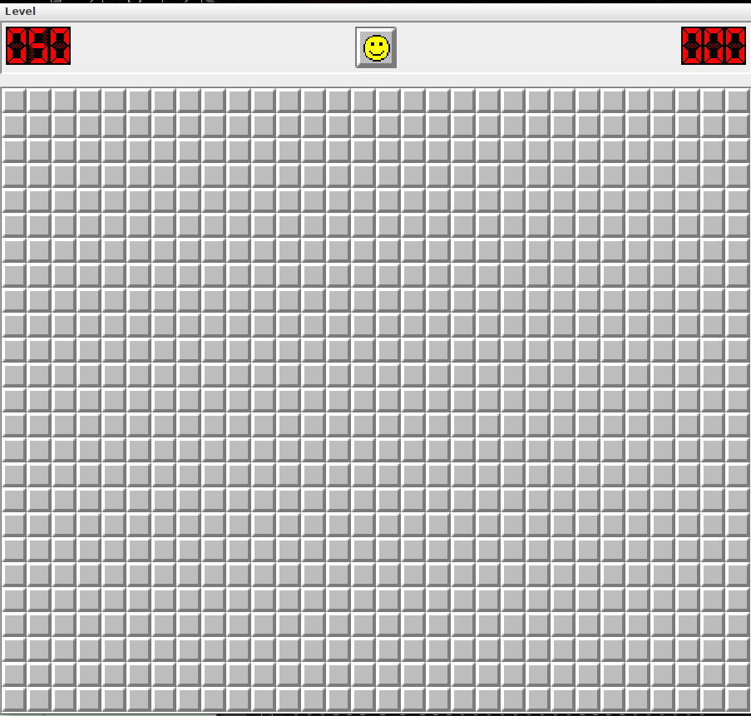

Figure 1. Minesweeper

### **The tools used**

* IDE for programming and debugging: IntelliJ IDEA, Eclipse
* Java Development Kit: 21.
* Mean of code version management: GitHub.

Figure 2. GitHub statistics

# **CHAPTER 2: METHODOLOGY**

### **Rules**

Key Rules of the Game:

When clicking on a cell:

* If it contains a bomb, you lose.
* If it's safe, a number appears, indicating the number of bombs surrounding it.



Figure 3. Example

* For instance: If you click on a cell with the value 4, it indicates that there are four randomly placed bombs in the adjacent cells.

### **Design**

* 1. *UI/UX*

Prioritizing UI/UX before our game's launch enabled us to gather valuable feedback from external sources, guiding us in establishing a consistent design pattern.

Minesweeper is a strategy and puzzle game that challenges players to locate hidden mines on a game board. The game requires a combination of strategic thinking and luck to succeed.

In this game, players click on unrevealed empty squares. When a square is clicked, several outcomes are possible:

* In case, no surrounding cells contain mines, the square is revealed as blank.
* In case, surrounding cells contain mines, the square displays a number indicating the number of mines adjacent to it.
* In case, a player clicks on a cell containing an unrevealed mine, it converts to a revealed mine, and all unrevealed mines on the board are shown. Consequently, the game is lost.
* In case, you suspect that a cell contains a hidden mine, you can flag it to prevent accidentally clicking on it.
* It is essential to avoid clicking on cells that contain unrevealed mines.

Crucial Components for Minesweeper UI/UX:

* Information to display:

Screenshot from 2024-03-19 11-41-32 

Figure 4. an unrevealed empty square Figure 5. an revealed as blank

 

Figure 6: an revealed mine Figure 7: an unrevealed mine



*Figure 8: Digits (‘1’-’8’)*

* 1. *Game algorithm*

After much iteration and troubleshooting, we now have the project structure as seen in the image below.

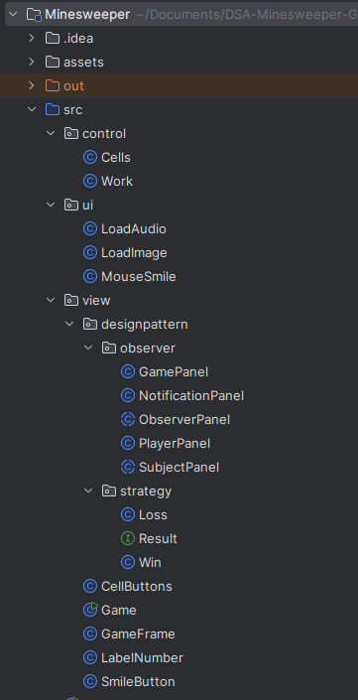

Figure 9. Project structure

The classes we teach can be arranged into distinct groups, like:

* UI: is a package to load audio, image and control the mouse so it contains LoadAduio class, LoadImage class and MouseSimle class
* Game: This is the main class of the game program. It contains the main() method and is used to initialize and run the game.
* Cell Buttons: This is a class that represents cells in the game. It can be displayed and interacted with by the user via buttons.
* Cells: This is a simple class that represents a cell in the game's matrix. It contains the (x, y) coordinates of that cell in the matrix.
* Game Frame: This is a class that represents the main window of the game. It may contain user interface elements such as buttons, labels, and other elements to form the game interface. This class can have methods and properties to create and manage windows, performing actions when the user interacts with the interface.
* Label Number: This is a class that represents a label in the game. This label can contain and display a number, information or status in the game. This class can provide methods to set and update the value of the label.
* Smile Button: This is a class that represents a smile button in the game. Commonly found in land mine games, the smile button is used to represent the game's mood state (e.g. happy, sad, worried). This class may have methods to change the smile button image based on the state of the game or user interaction.

Apply design pattern ( Observer and Strategy design pattern):

* Observer design pattern:
  + SubjectPanel: This is an abstract class inherited from the Panel class. This class represents a user interface element and is a "subject" in the Observer design model. It contains a list of ObserverPanels and provides methods to manage and notify ObserverPanels when there is a change in their state.
  + PlayerPanel: This class inherits from ObserverPanel and represents a specific user interface element. It contains a matrix of CellButtons and is used to display cells in the game. It also implements binding of mouse events to the cells and binds to the SubjectPanel to receive notifications of changes.
  + ObserverPanel: This abstract class inherits from the JPanel class and represents an Observer in the Observer model. It is connected to a specific SubjectPanel and will receive notifications when there is a change in the SubjectPanel's state.
  + NotificationPanel: This class inherits from ObserverPanel and represents a specific user interface element. It contains elements such as time, smileys, and remaining mines. It also provides methods to update these values based on the state of the SubjectPanel and display them on the interface.
  + GamePanel: This class inherits from SubjectPanel and also implements the MouseListener interface. It represents a specific user interface component and contains other components such as NotificationPanel and PlayerPanel. It also handles mouse events and interacts with Work (a class not defined in the documentation) to perform in-game actions.
* Strategy design pattern:
  + Result: This is an interface that defines the outCome() method. Other classes can implement this interface to handle the results of the game.
  + Loss: This class implements the Result interface and represents the loss result in the game. When the game result is a loss, the outCome() method will be called to handle related actions such as displaying a message, replaying the game, or ending the game.
  + Win: This class implements the Result interface and represents the winning result in the game. When the game result is a win, the outCome() method will be called to handle related actions such as displaying a message, replaying the game, or ending the game.

Apply Data Structure & Algorithm:

* Work: This is the class responsible for handling game logic. It includes methods for checking cell status, handling events when users click on cells, and calculating numbers for cells.
* Advanced Graph (Breadth-First Search (BFS)) and Matrix:
  + 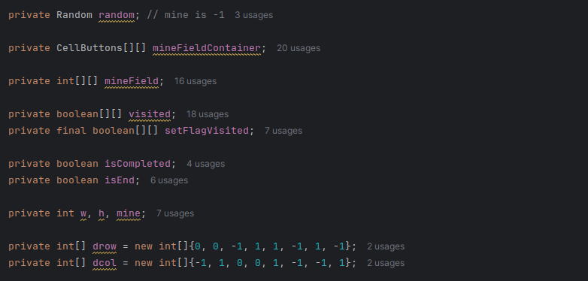
  + 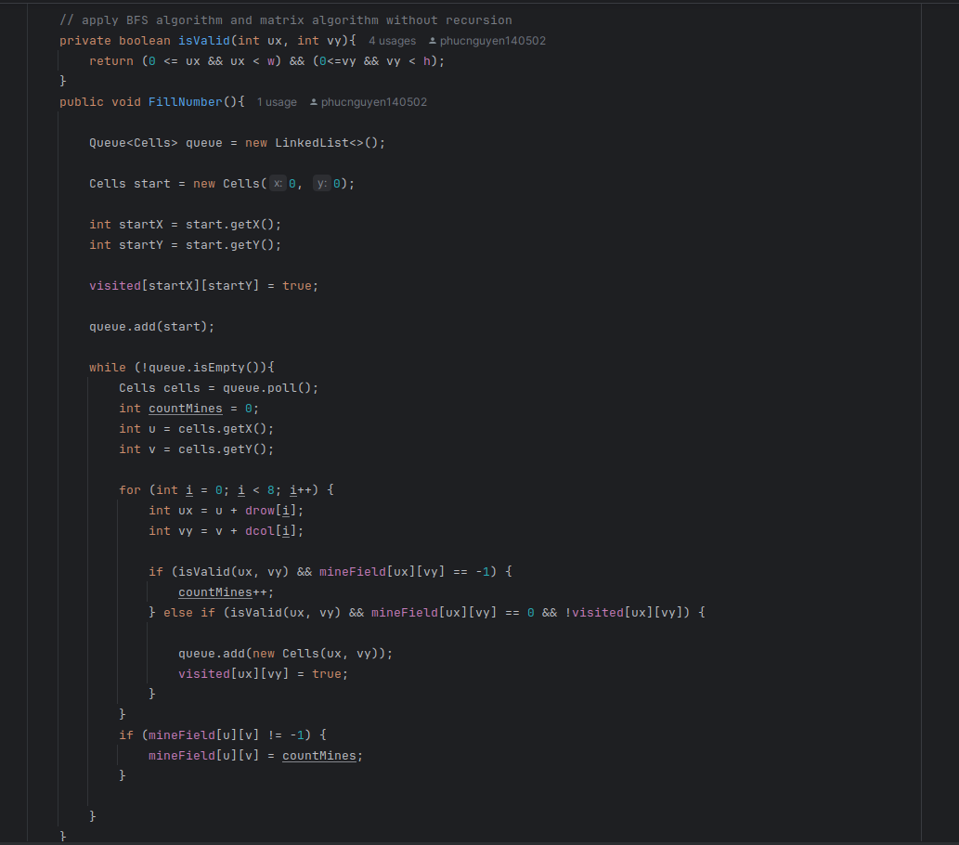

*Figure 10. Apply Advanced Graph (BFS)*

* Recursion:
  + 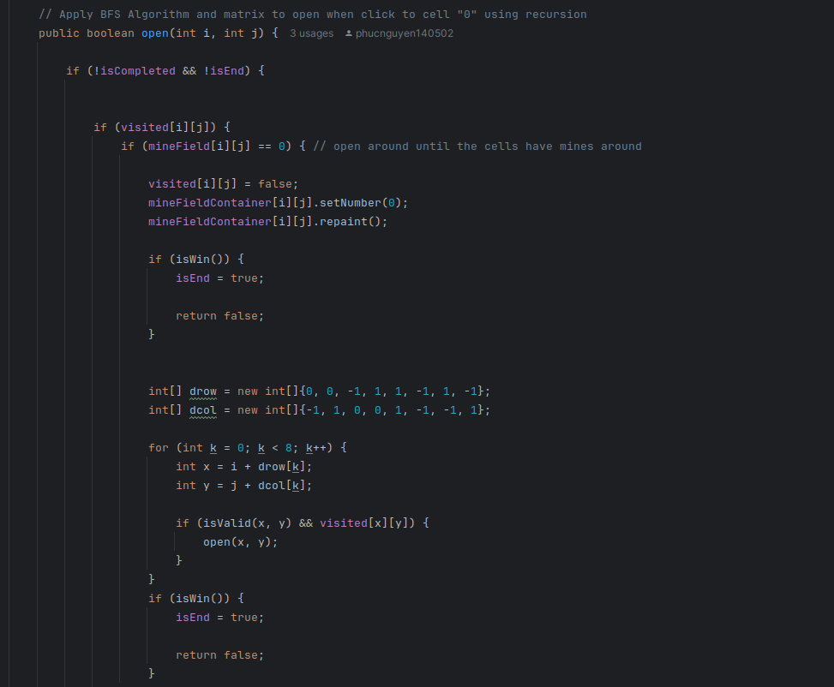

*Figure 11. Apply Recursion*

### **UML Diagram**

We provided the UML diagrams for the entire project and each group that was addressed to help you better understand the structure and methods.

* **Whole UML Diagram:** [Full UML Diagram](https://github.com/phucnguyen140502/DSA-Minesweeper-Game/blob/main/UML/uml.pdf), **access** to view the whole UML Diagram.

**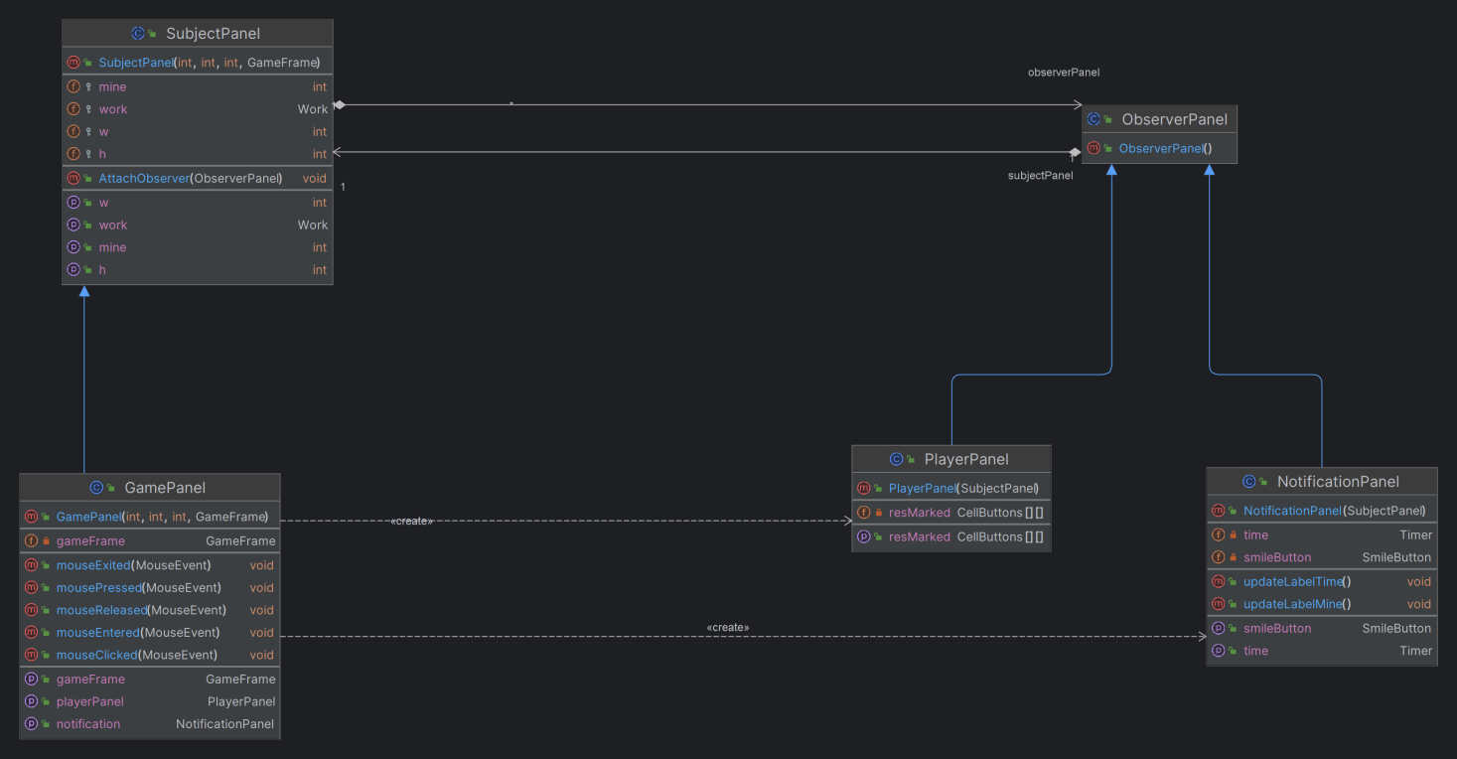**

*Figure 12. Observer design pattern*

**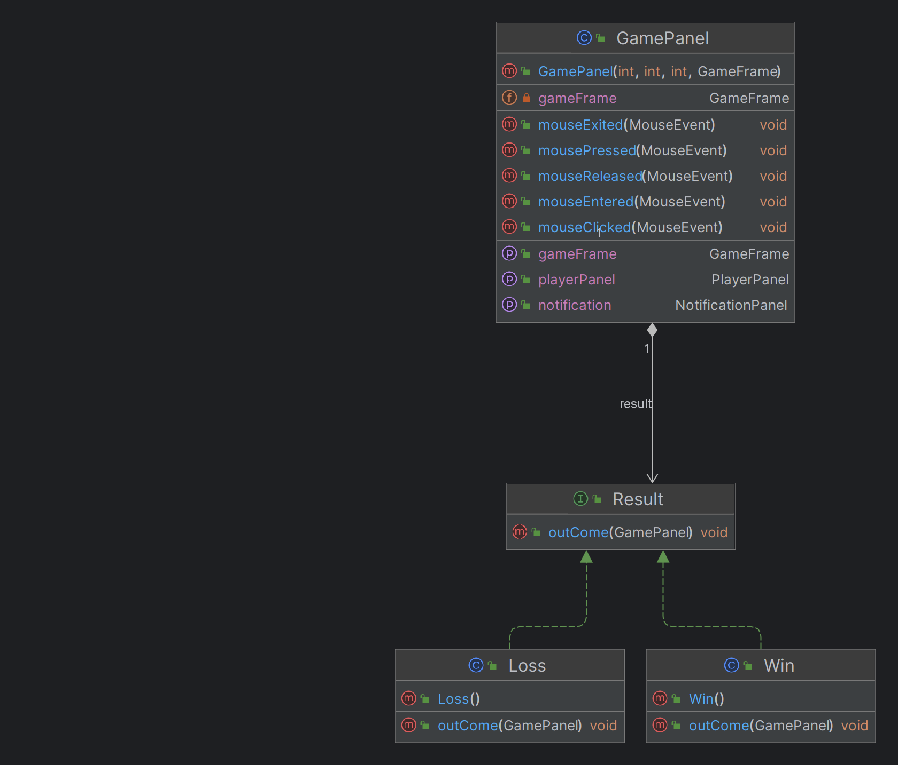**

*Figure 13. Strategy design pattern*

**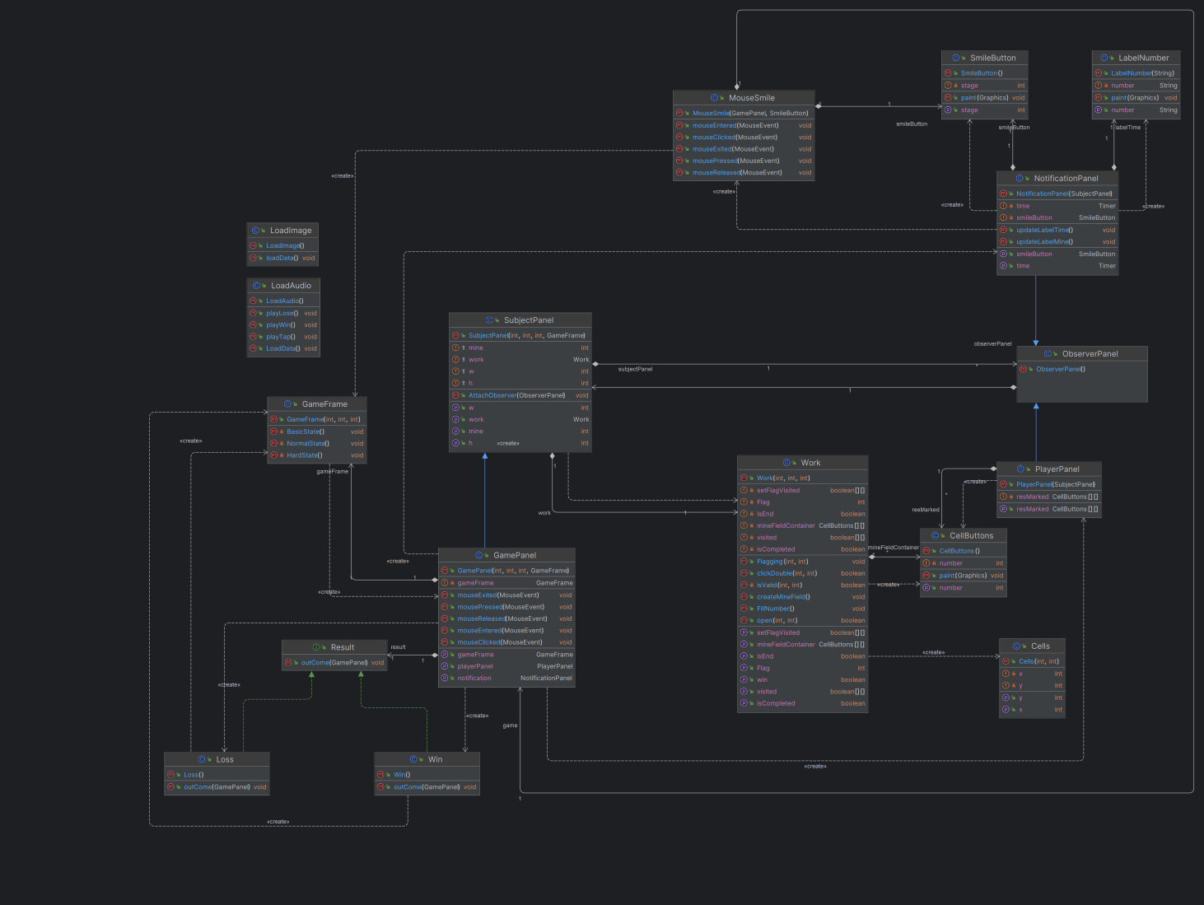**

*Figure 14. A whole of UML diagram*

# **CHAPTER 3: DEMO – RESULT**

To test our game on a machine that had an IDE and Java Development Kit 21 installed. We pulled our git repository and ran the Main class to launch the game. The following screenshot show some examples of the game states in the current build.

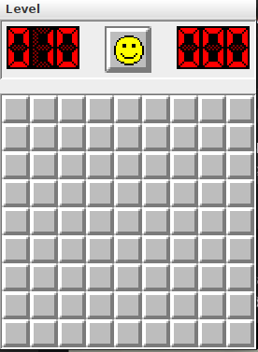

*Figure 15. Beginner Level*

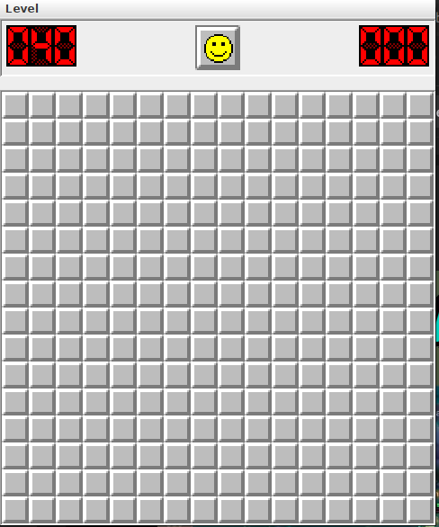

*Figure 16. Intermediate Level*

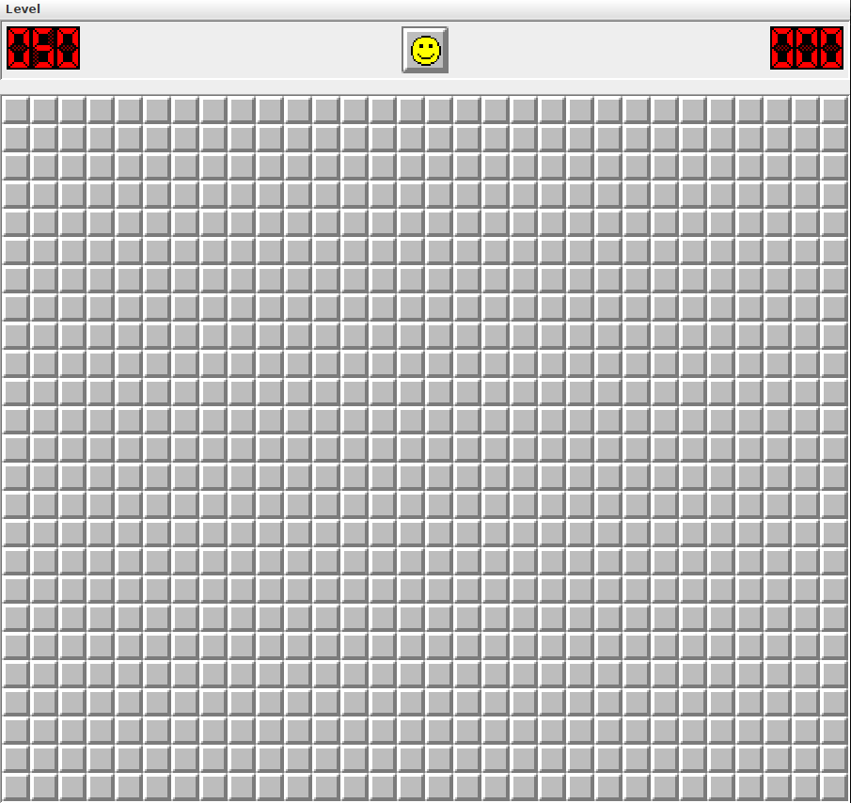

*Figure 17. Hard Level*

# **CHAPTER 4: CONCLUSION AND FUTURE WORKS**

### **Conclusion**

The game is currently being developed. I gained a stronger understanding of Data Structure & Algorithm (DSA), the SOLID principles, and the four key Object-Oriented Programming (OOP) components throughout the final term. This game has improved my skills in both OOP and DSA for game development, as well as for programming games that have additional features added after they are completed. The design pattern demonstrates the characteristics of object-oriented programming (OOP), such as inheritance, polymorphous, abstraction, encapsulation, and molecularity. It also demonstrates the application of BFS, recursion, observer and strategy design patterns, and SOLID principles. The wealth of knowledge gained in this endeavor is not only a testament to my collective expertise but also a testament to the innovative spirit that has driven me to push the boundaries of game development. The depth of knowledge I have acquired from this project is evidence of both my team's combined experience and my creative energy, which has inspired me to push the limits of game production.

### **Future works**

The following are possible careers (future employment) for the Minesweeper game:

1. Expanded the game to enable multi-players mode, enabling players to compete with one another in labyrinth solving or to play against one another.

2. Enhanced User Interface: Designed to deliver a more seamless and captivating gaming encounter. enhanced colors, sound effects, and tile display to boost enjoyment and interaction.

3. Statistics and ranking: Include player score ranking and useful statistics. enables players to assess how well they can calculate against other players, which encourages them to do better.

4. Integrated tip feature: Add a tip feature so players can get help when encountering difficulties in the game. However, careful technique is required to ensure the game's balance and tuning are not affected too much.

--> The work here opens up many opportunities to improve and expand the Minesweeper game, creating a fun and engaging gaming experience for players.

1. **Acknowledgment**

We would like to convey our deepest appreciation to our instructor and individuals who assisted us in reaching the goals of this project:

* Dr. Vi Chi Thanh
* Original code from Minisweeper in leetcode
* The sites Geeksforgeeks, Javapoints, JavaSwing and so on
* The README.md template from othneildrew (Drew, 2018/2022)

# **REFERENCES**

*[1]*Minisweeper in leetcode. (n.d) *Retrieved December 11, 2023, from*

*<https://leetcode.com/problems/minesweeper/description/>*

*[2] Java Swing Tutorial. Javatpoint. (n.d.). Retrieved December 11, 2023, from*

*<https://www.javatpoint.com/java-swing>*

*[3] UML Diagrams Tutorial. Javatpoint. (n.d.). Retrieved January 4, 2023, from*

*<https://www.javatpoint.com/java-swing>*

*[4] Drew, O. (2022). Othneildrew/Best-README-Template. Retrieved January 4,*

*2023, from*

*<https://github.com/othneildrew/Best-README-Template>*

*[5] SOLID Principle in Programming: Understand With Real Life Examples.*

*GeeksforGeeks. Retrieved December 28, 2023, from*

<https://www.geeksforgeeks.org/solid-principle-in-programming-understand-with-real-life-examples/>

*[6] [Playing music in a Java](https://stackoverflow.com/questions/27854171/playing-music-in-a-java-game" \t "_blank) game. stackoverflow. Retrieved December 16, 2023,*

*from*

*<https://stackoverflow.com/questions/27854171/playing-music-in-a-java-game>*

*[7] Data Structure & Algorithm: Understand With Real Life Examples.*

*. Retrieved December 28, 2023, from*

<https://techdevguide.withgoogle.com/paths/data-structures-and-algorithms/>

*[8] Data Structure & Algorithm: Understand With Real Life Examples.*

*. Retrieved December 28, 2023, from*

<https://techdevguide.withgoogle.com/paths/data-structures-and-algorithms/>